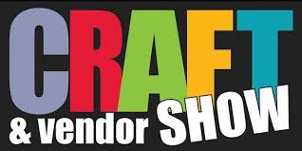

Bazaar and Craft Show
Good Shepherd UCC Tuckerton
170 Tuckerton Rd Reading
November 14, 2026 9am – 2pm
There are still craft table rentals available. Set up will be Thursday and Friday evening. Times to follow. Tables $15 (8 ft. table)
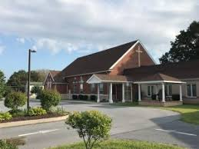

If you are interested in renting a table/area, please contact Carolann Seifrit at svcoachcarol@aol.com or leave a text message at 610-468-1765.

